CALL FOR EVS VOLUNTEERS IN SPAIN
MULTICULTURAL TOWNS
The Association IMAGINA is looking for 1 EVS volunteers motivated to work with children and young people in a rural area, about youth participation and development of key competences through non-formal educational activities.
Project title: Multicultural Towns
Project dates: 01.11.2018 - 01.09.2019 (10 months).
Location: Álora (Málaga, Spain).

The Hosting and Coordinating Organization:
ASOCIACIÓN DE DESAROLLO SOCIAL PARTICIPATIVO IMAGINA
The Association IMAGINA is a non-profit association with the main aim of promoting youth participation in our region of the interior area of Málaga, with the idea of enhancing civil participation in the social life of the town, promoting also learning opportunities and mobility for young people.
Social Innovation applied to Local development is our way of working, considering people like the key to solve their difficulties, whether they are social, environmental or economical. We believe in the power of young people to be active and innovative. Thanks to Erasmus + we have a path to transform our dreams in projects, allowing us to grow in a multicultural learning process.
Our association is integrated by people with different profiles (students, young people who are starting to work, youth workers, volunteers…) that have met thanks to the participation in other Erasmus + projects, discovering that we have common concerns and also common values that can be developed through this kind of projects and also with local activities, having also an impact in more local youngsters who can become part of this movement, so we can charge our batteries of energy, new ideas and youth initiatives that can motivate young people, make them learn, grow, improve their skills and act!
We have a really wide experience organizing youth exchanges and training courses, we are also a sending, hosting and coordinating organization for EVS, having a really good experience implementing projects about different topics through non-formal education.

The AIMS of Multicultural Towns
The goals of this EVS project is to dynamize our territory, increasing the opportunities for young people, their job, training and mobility opportunities but also giving value to their own resources and the possitive aspects of living in a rural area, while we open our minds to multiculturality.
The following activities are proposed to address that situation:
- To promote the active participation of young people of the territory, improving their employability, training and mobility opportunities, promoting also the relationships between people from different cultures and intercultural dialogue.
- To improve linguistic skills of scholars and young people with fewer opportunities, through activities after-school and support activities, using non-formal education methodology.
- To enhance awareness about the benefits of a balanced and healthy diet and the benefits of consuming local, organic and season products, especially among scholars and young people. We will use different games and activities such as cooking workshops and orchard keeping workshops, at schools and also at the Youth House. In this way, the children could visit it and work on it at the same time that they learn and enjoy.
- To support young people with disabilities and their families, throughout activities and workshops developed in rural neigbourhoods and small villages, making possible the necessary assitance so these youngsters could take part in the dynamization activities organized by volunteers with equal opportunities.

Some IDEAS of the Fields of Work that we will develop during this project...

- Linguistic Support and dynamization for Youth and Children:
These activities would be orientated to promote the participation of young people of our villages in activities and workshops which could increase their opportunities to learn other languages and to open minds. The volunteer will develop different workshops with the aim of:
- Improving the linguistic skills of young people with fewer opportunities. Linguistic skills are one of the most deficient areas of Spanish education and it’s also a big challenge for young people in Andalusia. With these workshops we want to promote learning not as an academic obligation but like a tool for communication among people from different cultures. To do this, the volunteer will be involved in Chat groups in English, French or other language, using non-formal education and dynamic activities (like cooking classes or dancing classes in other language).
Profile of volunteer:
- Good English level (B2).
- Competences on youth and children dynamization. Interest in working with them.
- Experience in fields like teaching, youth work, social work and non-formal education will be well valued.

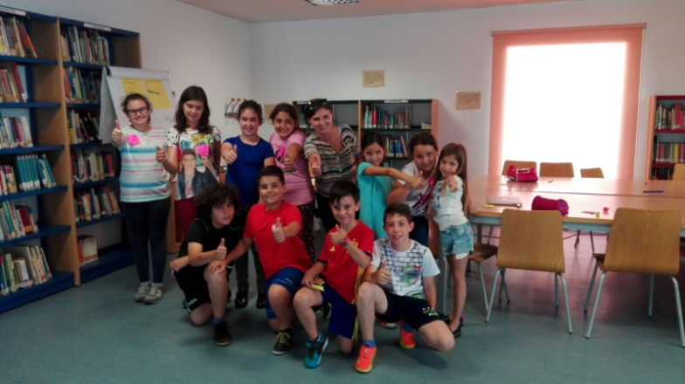

- Youth Dynamization and promotion of mobility programs
As a youth organization, we develop different activities in order to promote training, educational and mobility opportunities to young people from rural areas. To do that, we try to promote local and international mobility projects for youngsters within Erasmus + programme. Some of the tasks to develop will be:
- Support in the implementation of youth projects in our region (youth exchanges, training courses, Mediation project, etc.).
- Promotion of mobility programs such as Erasmus + and EVS: organizing workshops and dissemination activities, counselling young people, preparing them to go abroad challenging their fears...
- Helping the organisation with the work at the office related to organization of events, dissemination, promotion of activities, etc.
- Support to the activities of the YOUTH council at the town: organisation of activities for young people, employability workshops, healthy lifestyle and sport activities.
Profile of volunteer:
- Good English level (B1-B2) will be well-valued.
- Competences on youth dynamization. Interest in working with young people and passion for sports and active lifestyle.
- Digital Skills will be well-valued (video edition, photography, use of social networks, basic computer skills…).
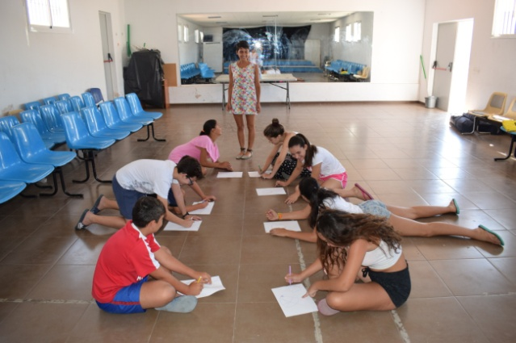
- New ideas and motivation to create activities for youngsters will be appreciated!

- Support to young people functional diversity
To support young people with functional diversity and their families, throughout activities and workshops, developed in rural neighbourhoods and small villages, making possible the necessary assistance so these youngsters could take part in the dynamization activities organized by volunteers with equal opportunities.
Profile of volunteer:
- Competences in working with young people.
- Some experience in the fields of occupational therapy, education, social work and youth work will be well-valued.
- Motivation to help.

Some common competences very important to us are:
- Motivation to work with young people from rural areas and to be involved in our organization.
- Interest in Rural Development.
- Capacity to build a trusting relationship with the youngsters.
- Capacity to work in a team with the other volunteers and the staff or the association.
- Some experience in the Erasmus + Programme and the organization of youth projects would be valued.
- Capacity to adapt to a rural environment.
- Flexible with the work, since some of our activities will be developed during the afternoon or weekends.
- Creativity, enthusiasm, new ideas are welcomed!

Technical Information:

Accomodation and Location:
Volunteers will be living in rooms (shared or single, depending on availability) in a shared flat/house with other EVS volunteers.
Within our organization, we develop activities in 2 different towns of Málaga: Álora and Pizarra. In this case, this project has as main place Álora, which is a town of 13.000 inhabitants, located in the interior part of Málaga.
This unique situation will allow the volunteer to live in a rural lifestyle, with the benefits that we have a wonderful wheather, fresh products and quiet lifestyle, but we also count with all the facilities like shops, supermarkets, sport centers, restaurants, etc.
BUT, for the people who need to live in a city or who doesn’t tolerate the problems related to rural areas (limited means of transport and limited availability of schedules, limited modern facilities like cinema, big shoping centers, etc.), think well about this before applying!

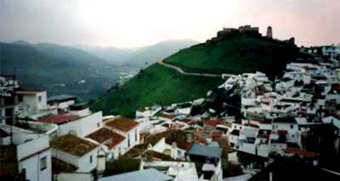

Food Allowance and Pocket Money:
Each volunteer will receive 150€ of food allowance and 4€/day for pocket money.

Transport money:
Each volunteer will receive the quantity according to the distance from the origin country to Málaga:
- Romania: 360€ maximum return travel.

Application:
To apply for this project, you have to fill the document PRE-SELECTION INTERVIEW, that you will find at the end of this document. In this questionnaire you have to sort, according with your preferences, the areas that you would like to be involved in.
Then, write your CV and your Cover Letter in english, saying why do you want to take part in the activity/project you chose and send them to: imaginaerasmusplus@gmail.com or to your SENDING ORGANIZATION, together with the PRE-SELECTION INTERVIEW.
Then, we will contact you by email to do a Skype interview.
After that, we will also communicate the results of the selection process by email...so wait for the answer, and good luck!

Deadline for Application: 29th october 2018.
Our Contact:
Organisation: Asociación de Desarrollo Social Participativo IMAGINA
Address: Calle Soleares, nº 12. 29500, Álora. Málaga.
Email: imaginaerasmusplus@gmail.com
Facebook: https://www.facebook.com/asoimagina/
Telephone: +34 60 67 64 685

Pre-selection Interview
Dear candidate,
Thank you for your application to our project Multicultural Towns.
To understand if this project and your profile are suitable to each other, we would like to have some information about your motivation and interests, so please, answer the questions below and send back this form, together with your CV and Motivation Letter to : imaginaerasmusplus@gmail.com or to your SENDING ORGANIZATION before the 29th october.

Some information about you

Surname |  | Name
Gender | Male  Female | Nationality
Date of birth |  | Place of birth
E-mail |  | Telephone

Why do you want to do an EVS project?

Why do you think you are the right volunteer for this project?

Please, give a description of your personality, in particular focused on strengths/weakness, values, aptitudes.

What are your plans after EVS?

Other information:
Special diet: -
Allergies: -
Any other information we should know:

Your sending organization:
EVS Database Reference Number:
Name:
Address:
Contact person:
E-mail:
Telephone number:
Skype:
Web:
Thank you for your collaboration!

