The Hosting Organization: Szatyor Association
SzatyorAssociationwasfoundedin2011,basedinBudapestandhasover100members.Ouraimis to draw attention to sustainable living, conscious consuming and community building. As an alternative eco-conscious association it is important for us to integrate healthy lifestyle, local, seasonal,organicandfairtradeapproachesintooureverydaylives.Throughoutourprogrammes,we intend to build a community by bringing people closer to nature and to natural food producing. We also organize farm visits to our producers to show eco-conscious farming in its authentic environment. On a regular basis, we create events of community cooking, cooking classes and attendfestivals.
see more on our website:www.szatyoregyesulet.hu/en

Etyek is a project of our association in a village 30 far from Budapest. Our objective with this project is to build a role model of eco-community as a solution for more sustainable lifestyle and be an educational point for mainly young people who want to learn and act on this field. Szatyor has been active in Etyek community for two years and plans to serve the needs of those who would like to learn more about sustainable solutions and participate in creating a self-reliable and resilient model of eco- community. For the next 3 years, we plan to establish an educational garden to demonstrate different ways of food growing, organize workshops (permaculture, deep-ecology, natural building, natural household technics etc) for the villagers as well for participants from around and Budapest and build up our community carpenter workshop for upcycling and restoration hands-on activites. Regarding our target group, our activities are open to all ages and backgrounds, however, we have a vision of involving youngsters of the village and provide them a community/non-formal educational possibility on sustainable and intercultural related topics.

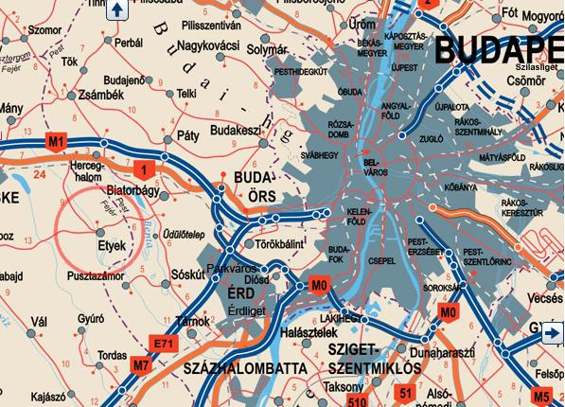
About the project of Szatyor Association in Etyek

SzatyorEtyek project`s activities will be held in Etyek. It is a village (3500 inhabitants) 30 km close to Budapest, therefore our activities targeting the local community as well city people. Etyek has a really unique social map. In one end, there are high-class touristic destinations in the village and on the other end families living in deep poverty. Many other layers in between, but the social scissor is widely open. Etyek keeps the tradition of the Svebish (sváb) culture. Basically, the village has mainly agricultural and touristic activities. There are one kindergarden and one elementary school. The civic life is active, there are several associations and foundations (ceramic association, choir, folk dance club, big families association, Svebish traditional house, etc), however, none of them are really targeting youth groups (14-30) of the community. The two closest bigger cities are Biatorbágy and Bicske.
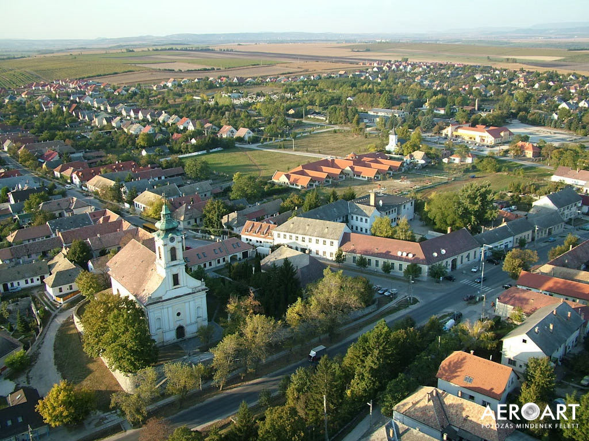
We see three main needs of the community where we have started to work on and in the future would like to include EVS volunteers. Based on these needs, we are planning 3 activities with 2 volunteers working on each activity.

Volunteer Programs:
Early Greens youngsters for making our village a vibrant green meeting point Since the closest and mostly preferred highschools are in Budaörs and in Budapest, youngsters of the village will have to bond with classmates and other young people from different communities. We often experience that young people of the village do not find 'exciting' enough to stay in Etyek for their free time or long term. We would like to provide opportunities where they can join in intercultural activities, 'trendy' initiatives in order to find suitable activities also after they leave the elementary school and have a positive attitude towards their home village.

Multi Greens intercultural learning and social impact of eco-conscious community Thenumber of families moving here from Budapest is significantly increasing. These families have the need and openness for learning about and being active in sustainability-related topics and communities. Plus that many of these families speak foreign languages and they would like to provide a multicultural environment for their kids that they could easier access in Budapest. We aim to integrate young people and their families with difficult social background into this open and multicultural community.
Growning GreensHowever Etyek is an agricultural place, family gardens are loosing their purpose of providing food and people are forgetting the knowledge and the joy of growing and producing food for their own use. With our Szatyor (educational) Garden, we would like to bring these back.
Of course there will be plenty of opportunities that the volunteers take part in each others` activities, but 2 volunteers will be responsible for one area.

All activities are open for volunteers, but these are the 3 focus of our activities.

Volunteers` profile
Background of the participants can be varied, the most important in the commitment and the openness to learn. Our aim is to involve young people who want to know more about sustainable living in the countryside, community building, organic farming, food sovereignty and to improve their own choices about everyday consumptions and self-supporting skills.
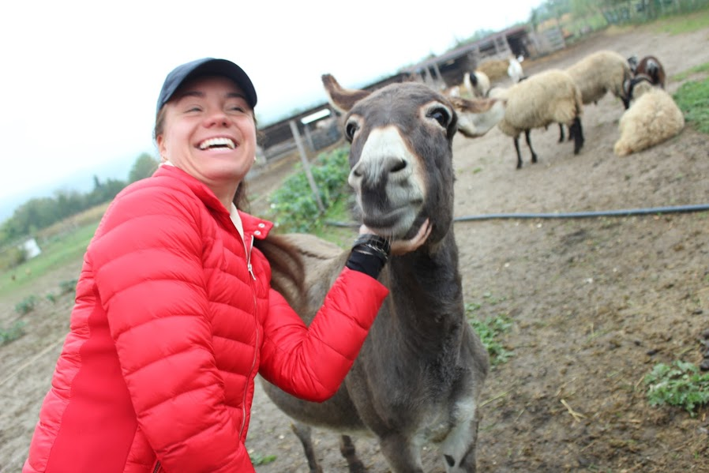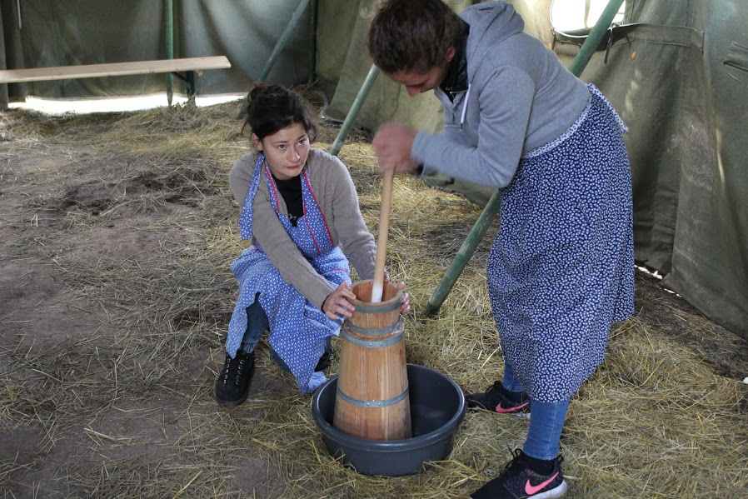

Activities
We have designed and put together the activities that each key competences can be developed based on the volunteers` interest and learning objectives. We emphasize on developing the intercultural and social competences of the volunteers and these are also the most important goals we would like to work on with the local community of Etyek. Among many activities these can be involved in working in an international team, contact with local people / who might not speak that easily the common language/, organize workshops, events, and share skills, knowledge and experiences with others. Also on the Etyek market volunteers will have the opportunity to create and exchange goods, so their entrepreneurial skill will be focused as well. All international volunteers will learn Hungarian from a local English teacher, Bea, therefore communicating in foreign languages competence will be touched as well. Plus as it will be an international volunteer team, they will have the opportunity to get to know each other's languages. The common/working /language is English.

Communicating and manage their life in this language will provide a great learning in this field. Among the everyday activities, it will be editing social media, making research on certain topics on the internet and so on, so we will often work on developing their digital competence. Mathematical competences can be improved by calculating with their pocket money and food allowance, plus if the volunteers organize a local or bigger event, workshop, the budget will be also created by them.

Our project offers various new knowledge and practical learnings on permaculture, different cooking and dietary approaches, sustainable life and system thinking, upcycling, vermicomposting and organic and biodynamic farming. Apart from the general skill development, we create a learning plan with each volunteer based on their personal and special interest. This can be something not directly connected to the organizational activities, but we can support the volunteers in these learning initiatives / mini projects.

Based on this learning plan, we monthly monitor (coordinator and mentor as well) how the learning goals and the connected activities and happening and fulfilled. If needed, these plans can change, but it means a good base for more conscious and planned personal development. This plans and monitoring will also be the base for final evaluation at the end of the project and also means a great support for writing the Youthpass.

Practicalities
Accommodation
The 6 volunteer will be accommodated in a 100 sqm house in Etyek. 2 volunteers will share one room and 3 will share 1 bathroom (so there are 2 bathrooms and toilets). In the house, there are: a big dinning room and a kitchen, the volunteers will share. The house is centrally located, the local bus is 3 minute far, the shops are 5 minutes. The house has a quite large garden that the volunteers will take care together and produce partially their own food. The cost of the rent and utilities are covered by the hosting organization.

Food and pocket money.
Volunteers get 130 EUR food allowance per month that they can spend according to their own need. We support local, organic and seasonal food. The garden gives the opportunity to cultivate and produce food (we support them in this activity). The shared kitchen gives the space for cooking and also we will have a common cooking and eating every Friday together the staff and the volunteers. On the top of the food allowance, volunteers get 120 EUR per month pocket money.

Transportation
In the village we provide bikes for the volunteers for easier transport as many people bike in the village. In case of transportation to Budapest, if it is related to volunteer activities, the organization covers, in other case volunteers cover.

Language support
Volunteers will be provided by Hungarian language lessons with a local teacher. They can also create language club with locals to practice Hungarian.

For further information and application, please write us to evsszatyor@gmail.com

