Project summery
EVS-European volunteer service is the best way to learn, share and explore. Long term project ,,Open youth house’’ is one of the Erasmus projects held in Finland, Turku. Project dates ( 01.09.2018 – 31.08.2019 ) Receiving Organization is ,,Turku youth services’’, which is in charge of Youth activities and events in Turku city. Organization is financed by Turku government, all the staff have a special education and you have a chance to work with professionals in this field.
During most of the year, the volunteer will be involved in youth house activities with youngsters (age 9 to 18). Thevolunteer will take part in the planning, implementation and evaluation of the activities. The volunteer participates inthe free-time activities with youngsters in the same way as the other employees.To concrete, volunteer will be part of organizing special days for girls and boys, as well as festivals, New year party, Halloween, lauste day and lot kind of colorful events. Volunteer is obliged to do cultural day of his/her country at work place and Also organize cooking classes for youth. Not only indoor activities will be planned, there will be girls camp, family camp, going to cinema with youngsters and excursions in adventure parks. All the events will be held in different places and even in different cities.
At the same time volunteer can be involved in other activites and trainings which is organized by ,,Turku Youth services”. Usually there are musical festivals, handicraft events and special celebrations for special days which is traditionally in finland.
The working hours of the volunteerare in general from 13 am - 21 pm and the work takes place during weekdays and sometimes weekends. Volunteerwill work 5 days a week 7 hours a day (4 evenings and 1 morning working day).Volunteer has 2 days off in every month except weekend, so you can also collect it for summer. According to finish working rules, if you are working extra ours 7h+1,2,3 , you can also collect it, and when it gets 7, take an extra day off. Co-workers and working atmosphere is very nice and helpful.
When the summer vacation comes, Youth houses are closed, so for one month volunteer is working at ,,Adventure park’’ which is Turku’s one of the biggest park, full of entertain mental activities for children. Volunteers will be working at one of the point ,so you can choose.
At the end of project, Volunteer is getting ,,Youth pass certificate”, where fields of benefits should be filled by volunteer.
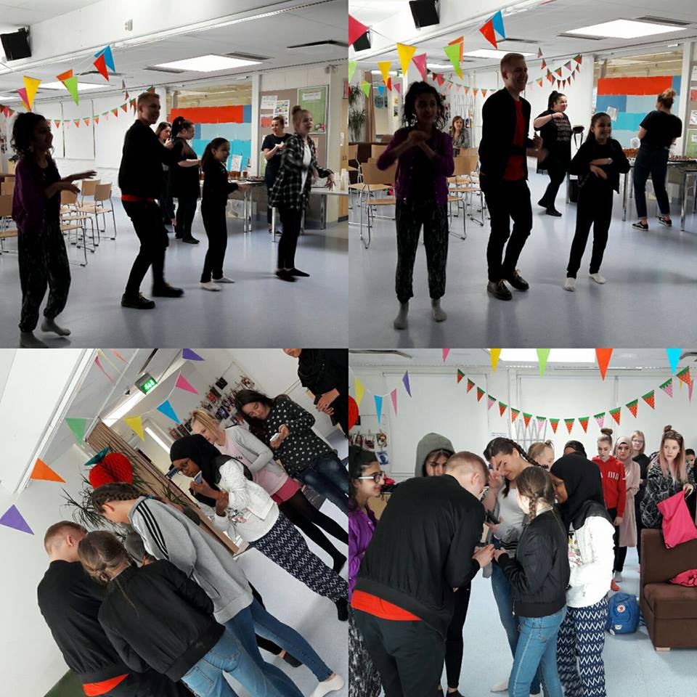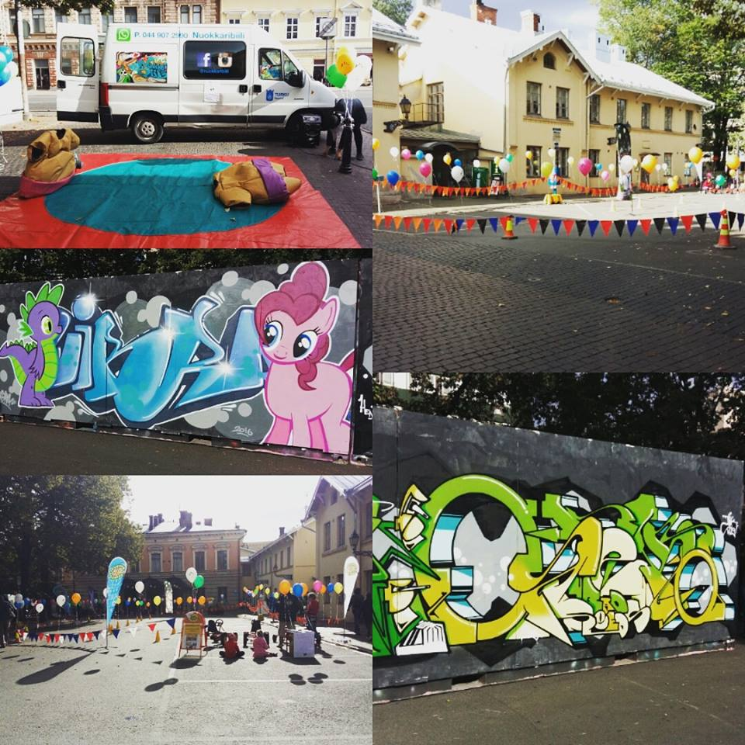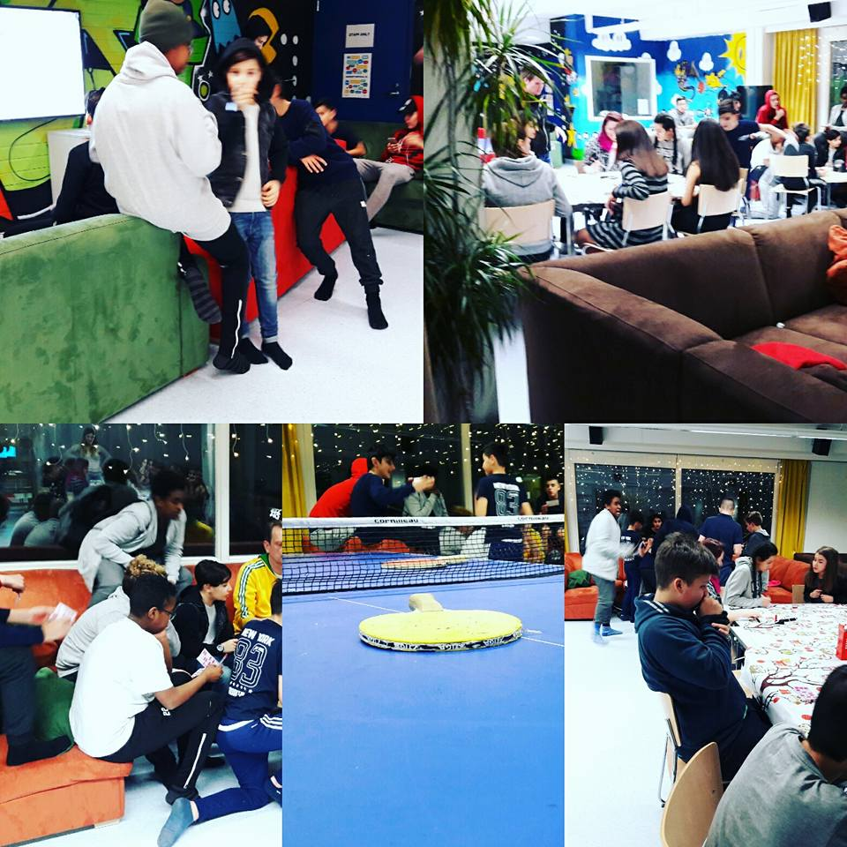

Accomodation ,food and transportation
Volunteer will live with one flat mate in quite comfortable flat close to city center. That’s because its Finland, every block of flat has a sauna, very good heating and facilities you need. All the payments connected to house and other expenses connected to projectis covered by the European Commission Erasmus + program.
Volunteer is getting 200€ for food. Shops are close to every district and in centrum as well open till 9:00.Volunteer is also getting pocket money 125€ for additional needs.
Bus card which is valid in Turku and close cities like Naantali, Kaarina etc. will be provided by organization. Also Volunteer will have a bicycle. Moving by bike is absolutely safe in Finland, because city has bike ways everywhere.
That’s because volunteer’s working place is governmental, Turku government is giving to its workers free wifi in their buildings. Also volunteer will have special bracelet, which can be used in gyms, swimming pools, museums etc. in Turku.
Volunteer will also get finish telephone number and work phone, in case its needed. Local calls messages and internet is covered by organization.

courses and trainings.
After arriving Finland, volunteer will have a free language courses during 3 month. Language course hours are also working time.
In the endof EVS’s first month, Volunteer will have an arrival training in another city, with whole EVS team in this country. This 7 days will be very useful for coordination and for having new friends and known people around Finland to visit. Travelling fees, accommodation and food will be covered.
After 6 month of project Volunteers have mid-term training for 3 days, where they will sum up project and talk about advantages and disadvantages, with same people from arrival training in another city. All the fees are covered here too.
Remember that you have to sign up for the trainings before head.
Health insurance
Volunteer will have an health insurance named ,,Cigna”. Insurance is financing most of the services as well as dentist fees. Volunteer is paying for service, then submitting online claim. After this volunteer is getting money back on his bank account. Health care institutions are very modern and trustful in Finland. Please, bring your European health card, if you are a citizen of European Union.
Place
Turku (south-west Finland) in ex-capital of Finland, 2 hours way from Helsinki. Absolutely safe City with 180.000 inhabitants. Town has a river sides and 26.000 island around. From here you can take a ferry to Stockholm. As the locals are saying Turku and its surrounding are separate culture in Finland. Winter in Finland is strict , but not so much in Turku. Temperature varies from -8 till -25 .Winter time its getting dark very soon, for example at 4 it will be already night. You should not miss Christmas time in Turku. In this city they are preparing for that very specially. Do you know from where is santa? Off course from Lapland, Finland. Santa claus village you can visit whenever you want, but I advice you to do it in winter.Here you have a possibility to see northern light, which is amazing. From here you can travel to Scandinavian and Baltic countries too very easily by ferry.Donot forget to try ice fishing and ice swimming after sauna. At the same time, everybody says that Turku is a best in summer. Here comes a lots of ships, which are bars and cafes. You will explore lots of nature, lakes and healthy life style here. In turku they have their own running races for charity as well. And off course white nights ! In summer its not getting dark at night time at all. That’s very interesting and nice thing, which you can see only in northern countries like Finland. Weather in summer is not so good, varies from 16-22c, mostly raining and cloudy.During a year you will get a pleasant from lot kind of markets in turku, I have to underline traditional one. Finland is the country of musical festivals. One of the worlds famous festival is ,,Ruisrock” which is on an island ,,Ruissalo”, very close to Turku.
Turku have a 6 universities here, so town is full of international people as well. Here you can join diversity of clubs, like contemporary art, old finish traditional dances, zumba classes, antic fighting etc. You can also very easily get a library card and choose your favorite book from very huge diversity in main library building.
