Erasmus Plus

Connecting Through Volunteering



  - UK- Dudley

  - July 28th 2018-July 27th 2019

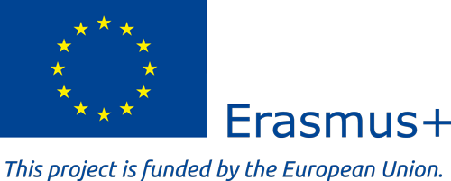
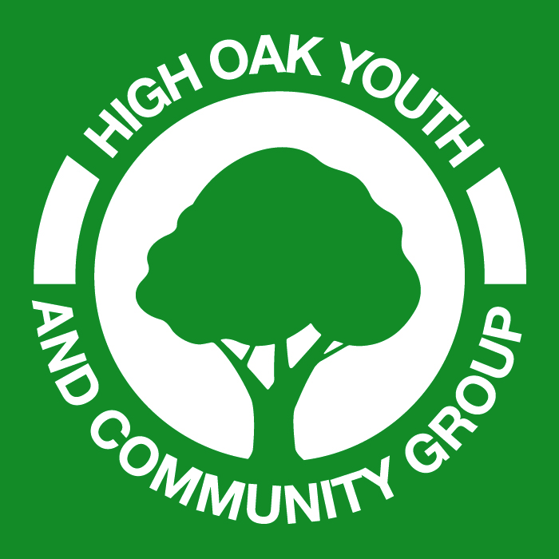
  - Information Booklet

Summary of The Project
The Connecting Through Volunteering Project has been developed by staff, volunteers, students on our programmes, working with the community, volunteers and mentors.
The Volunteering projects we have carried out, have been very successful and the young people involved felt that this would be a great idea to get other young people involved sharing their cultures, their experiences and also learning about other cultures and what’s going on with other young people.
The project will engage the Volunteers in the skills of youth and community work. They will work with young people Face 2 Face, hands on projects, sharing and developing programmes using their pre-exiting skills and newly developed ones.
We will work with Volunteering 18-30-year old of mixed ages and genders. They all have a range of diverse skills, which will add quality and strengthen the project we plan to carry out.
The project will be based in Dudley and work across the Black Country. The project aims to create a small group of young people from different countries who will steer the project working with other young people, leaders and community groups.
They will use community events, celebrations, discussion groups and workshops. As well as various social media methods to get other people involved in the project.
The group will be celebrating young people and what they are doing in their local areas. It will be about young people sharing their stories and experiences, through Blogs, Facebook create newsletters and articles not just in the UK but also across Europe and Mediterranean the countries where we already have some very good partnerships happening.
The groups will also be involved in the day-to-day work at High Oak and be really engaged with the local communities. They will be able to create programmes around supporting other young people, seeing how we can learn from each other and gaining valuable experience whist doing the project.
The project will engage Volunteering participants from Austria, Spain, Romania, Turkey, Greece and Germany. Working on a Volunteering programme for twelve months.
We will engage 10 students in total, in creative and inspiration youth and community programmes.

High Oak Youth and Community Centre are happy to Host you in the small town of Dudley West Midlands. There are two house you will be bases either at:
17 Pebworth Grove 35 Junction Street
Dudley. West Midlands Dudley. West Midlands
DY1 3BQ DY2 8XT
You will stay in shared rooms. The accommodation has all the normal house hold equipment, so you do not need to bring anything with you. Unless you want to bring hair curers or straighteners.
You will be expected to maintain the house, keeping it clean and respecting the equipment and furniture.
If items are broken due to lack of care or constant misuse, they will need to be replaced by the volunteer.
You will be requested to come on a pre visit (APV) for up to two days from 4-6th June or 29th June –
1st July 2018.
We will also have a Skype meeting with each participant before the placement is confirmed.
The programme will run over a period of 12 months from 28th July 2018 - 27th July 2019.
If volunteers want to go home for Christmas they can keep some of their holiday days and leave around the 23rd December 2018.
HOYCC are requesting that all participants attend on the start dates as much as is possible.
We will enclose an Activity Agreement Document, which will need to be signed by you and the sending organisations. This will need to be brought with you when you start your Volunteering Placement in the UK.
This will act as a contact and agreement for the EVS programme.
Your roles are included in the Activity Agreement pack but we also need you to be flexible as all our programmes work on being flexible with the groups we work with. You will be assigned a mentor when you arrive and you will receive an induction into the programmes, the organisation and the local community.
We have created a Facebook Page, so you can begin talking with our current EVS, High Oak Youth and Community Centre and with each other. You can also check out and see what we are up to.
High Oak Youth Group/Projects

Travel

You can book flights from the 1st June 2018
If you are unable to cover the cost we can book them for you but if you can book them and sort out travel you will be reimbursed when you arrive in the UK.
Please note you must keep all your travel documents and boarding cards, as we
need these to be refunded by the British Council.

Break down of travel cost:
Austria = 275.00 Euro x 2 students
Romania = 360.00 Euro x 2 student
Germany = 275.00 Euro x 2 students
Turkey = 360.00 Euro x 2 students
Spain = 275.00 Euro x 1 student
Greece= 360.00 Euro x 1 student

Please keep within the budget if you are having any problems let us know, as we are not able to pay over the above cost.

You will need to travel to Birmingham Airport as this is the nearest. Due to cost it may
work out cheaper to fly to Manchester or one of the London airports but you will also need to include travel to Birmingham.

Travel into Dudley from Birmingham Airport
From Birmingham Airport you will need to get the shuttle to the train station, this is
free. The Shuttle is upstairs in the airport opposite Burger King. You will then need to get a Train to Sandwell and Dudley. Try and get a direct Virgin Train, other wise you will have to change in Birmingham.
You can also get a local train. Ask at the information desk.

The trains will take you into Sandwell and Dudley where we will arrange pick-ups.
Call or WhatsApp me and let me know what time the train will get to Sandwell and Dudley.

https://www.virgintrains.co.uk/stations-destinations
https://www.virgintrains.co.uk/travel-updates/train-timetables

Local travel around Dudley will be via Bus, car sharing and bikes.

Roles and responsibilities

Roles and responsibilities
Each volunteer will be given their roles and responsibilities on a monthly basis. You will be offered regular support in the roles given.
The roles will include:
Working at the local youth centres, supporting the staff and working with the youth groups to come up with creative ideas for the youth club activities.
Working alongside our 13-25 teaching and employment support programmes sharing skills, personal development and expertise.
Peer to peer support with other volunteers sharing skills and intercultural understanding.
Active participation in the local community, looking at sports, arts and social media supporting local groups and young people.
Supporting the Centre for Equality Project in the local area.
Working with a school for young people who need extra support in their learning.
Creating new programmes in the area working with other volunteers and youth workers, through listening to the young people.
Supporting High Oak and its partners in carrying out their programmes, IT support, marketing, social media support and creating active blogs and web pages.
The volunteers will have the opportunity to develop programmes according to their own interest through co-operation with local groups, parents and community members.
You will also work with us to support the local soup kitchen and food bank programmes.
Finance.
The financial support in form of Pocket money for the mobility period has a maximum amount of 140 Euro per month.

Participant’s will also received additional food money (120.00 Euro’s per month) the details are all included in the activity agreement.

Preparation
The EVS should attend pre -departure training in person or online.
The sending organisation will support the Volunteer in preparing for the placement
- Cigna insurance,
- Police Checks – these should be translated into English and brought with you at the start of the project.
- COS numbers working with High Oak Youth and Community Centre
- Visa papers
- Activity Agreements these should be signed by you and your sending organisation and brought with you when you start the placement.
- AOB

Please think about the commitment you are taking on as it’s a big commitment but will be very rewarding. Please make sure you are able to complete the full 12 months duration of the project.
- If the participants leave before the 12-month placement is completed, they will be required to fund their own return travel cost.
- Holidays will be discussed once you arrive. Each volunteer will have their own holiday form and holidays must be requested and granted before they are booked.
- Holiday will not be granted during High Oak holiday projects.
- You are required to partake in the full programme of activities and projects with High Oak and its partners.

High Oak Youth and Community Centre work with a lot of young people with fewer opportunities in areas of deprivation and with low-income families. A lot of the work we do is tailored to the needs of the young people and the community.
Our aim is to support young people in the community through our programmes and to design programmes around their needs not ours. Your role as an EVS volunteer will be to help us support the young people and the community. You will be required to work 30-38 hours a week dependent on the programme we will be running at the time. You will be required to work during the day and some evening also some weekend work will be required. You will get at least 2 days off each week.
You will be supported at all times during the programmes. Our aim is that you will share your skills, knowledge and experience with the groups we work with and that we in turn will all learn from each other during the Connecting Though EVS programme.
Please bring your enthusiasm, motivation and also your individualism, as this is required for a successful programme.
Flexibility is a MUST!!

Contact details
High Oak Youth and Community Centre
34 High Oak
Pensnett Dudley
DY5 4LA UK
enquiries@highoak-youth.com
www.highoak-youth.com
Face book:
High Oak Youth Group/Projects
Twitter:@highoakyouth
Contacts
Angela Edwards - +447977506222 or +447982428831
Katharine Jukes - +447515945145
Our Partners
ASOCIATIA DE TINERI DIN ARDEAL
AC Amics de la Biblioteca de la Fonteta
CUBIC – Culture & Education in Context
Eurocircle Deutschland e.V.
SINDESMOS YAYGIN EGITIM MERKEZI DERNEGI
SISTIMA KAI GENIA

